Ex - 10 : Virtualization

# Nithin Prasath C – 22BCS081

## AIM:

## To install and configure Hyper-V on a Windows Server 2012 environment, enabling the server to create and manage virtual machines for the purpose of consolidating workloads, improving server utilization, and creating a flexible, efficient, and scalable infrastructure.

## DESCRIPTION:

The task involves installing and configuring Hyper-V on a Windows Server 2012 environment. Hyper-V is a hypervisor-based technology that allows you to create and manage virtual machines on a single physical server. By enabling Hyper-V, the server can efficiently consolidate multiple workloads, reducing hardware costs and improving resource utilization. This setup provides a flexible and scalable infrastructure, ideal for testing, development, and production environments, enabling better management of computing resources and ensuring optimal performance across virtualized systems.

## OUTPUT:

#### Downloading and installing Oracle VM VirtualBox in our PC:

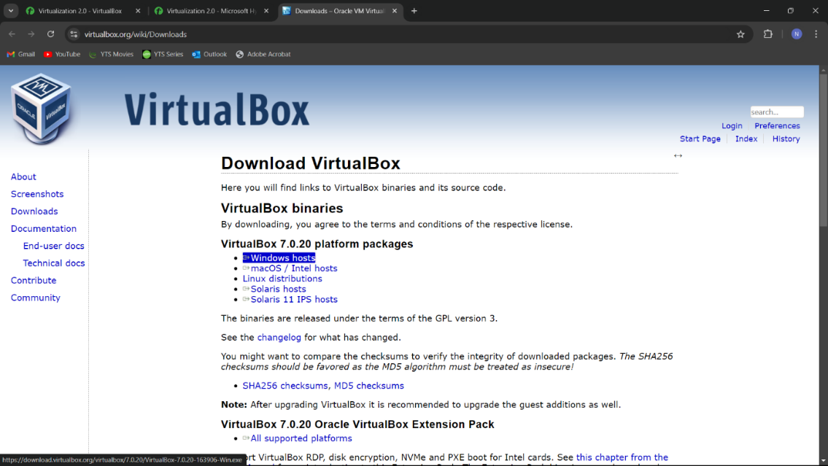

#### Installing Windows Server 2012 R2 in virtual Machine

#### Installing Hyper-V in virtual machine:

## RESULT:

The successful installation and configuration of Hyper-V on Windows Server 2012 enables the creation and management of virtual machines, optimizing resource utilization and providing a scalable virtualized environment.